Breeder :  Mr R Davies  address  address  address  Phone : 1234-567891  Email: your email  www.burnthwaitessiamese.co.uk | Burnthwaites Scarlet-Fever  GCCF Reg No: CS ****** Breed Number: 32a  Colour: Red Point Siamese Sex: Female Date of Birth: 20/02/2011 | 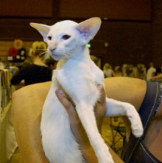 |  | Owner :  Mr New Owner  address  address  address  address
Remember to visit www.siamese-cat-breeder.co.uk for show results and cat photos. Visit latest-mews.siamese-cat-breeder.co.uk for cat hints, tips and tricks.
Parents | Grandparents | Great Grandparents | Great Great Grandparents | Great Great Great Grandparents
SIRE  Champion  Karamushi Cheeky Chester  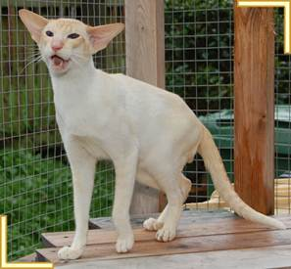  Colour: Red Point Siamese  Breed No: 32a  Reg No: CS | SIRE  Example Cat  Colour: Chocolate Point 24b  Reg No: CS123456 | SIRE  Example Cat  Colour: Cinnamon Point 24k  Reg No: | Example Cat  Colour: Cream Point 32c | Gr. Ch. Sunjade Soda
 |  |  |  | Merescliffe Ashara
 |  |  | Example Cat  Colour: Red Point 32a | Ch.Westgarth Sundance
 |  |  |  | Gr. Ch. Wesgarth Amber Witch
 |  | DAM  Example Cat  Colour: Cinnamon Point 24k  Reg No: | Example Cat  Colour: Cream Point 32c | Ch. Rimana Pavarottii
 |  |  |  | Ch. Chaijon Celestine
 |  |  | Example Cat  Colour: Red Point 32a | Ch. Ginnistam Infidel
 |  |  |  | Gr. Ch. Adentsh Fiordalisio
 | DAM  Example Cat  Colour: Cream Point  Reg No: CS123456 | SIRE  Example Cat  Colour: Lilac Point 24c  Reg No: | Example Cat  Colour: Cream Point 32c | Ch. Kariwowl Theiceman
 |  |  |  | Ch. Rantipole Betelguese
 |  |  | Example Cat  Colour: Red Point 32a | Sunjade Brandysnap
 |  |  |  | Anorwa African Queen
 |  | DAM  Example Cat  Colour: Lilac Point 24c  Reg No: | Example Cat  Colour: Cream Point 32c | Gr. Ch. Shermese Culpepper
 |  |  |  | Ginnistam Geisha
 |  |  | Example Cat  Colour: Red Point 32a | Gr. Ch. Swanky Sonofagun
 |  |  |  | Finetime Ferengi Rani
DAM  Champion  Billstes Maddamcin  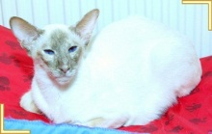  Colour: Cinnamon Tortie Point  Breed No: 32b7  Reg No: CSSR | SIRE  Example Cat  Colour: Chocolate Point 24b  Reg No: CS123456 | SIRE  Example Cat  Colour: Lilac Point 24c  Reg No: | Example Cat  Colour: Cream Point 32c | Ch Felitan Maverick of Sotto Bosco
 |  |  |  | Myfun Penny Candy
 |  |  | Example Cat  Colour: Red Point 32a | Gr Ch Hautechat Franklin of Sum Thai
 |  |  |  | Felitan Oliver of Sum Thai
 |  | DAM  Example Cat  Colour: Lilac Point 24c  Reg No: | Example Cat  Colour: Cream Point 32c | Int Ch Rama Whats Wanted
 |  |  |  | Gr Ch Rama The Heat Of The Night
 |  |  | Example Cat  Colour: Red Point 32a | Eur Ch Okonor Kond
 |  |  |  | Ch Okonor Tinuvirel
 | DAM  Example Cat  Colour: Cream Point  Reg No: CS123456 | SIRE  Example Cat  Colour: Lilac Point 24c  Reg No: | Example Cat  Colour: Cream Point 32c | Lanimax Misterman
 |  |  |  | Ch Mylynn Mauya
 |  |  | Example Cat  Colour: Red Point 32a | Gr Ch Sarnau Johpasquali
 |  |  |  | Gr Ch Sarnau Powdernpaint
 |  | DAM  Example Cat  Colour: Lilac Point 24c  Reg No: | Example Cat  Colour: Cream Point 32c | Rimana Cream Blaze
 |  |  |  | Legsby Totally Devoted
 |  |  | Example Cat  Colour: Red Point 32a | Ch Legsby Red Rebel
 |  |  |  | Ch Legsby Troubleenstrife

I certify that this pedigree to correct to the best of my knowledge Signed Date

